Reference Format for Application Materials
The Third Hengshan Calligraphy Award
Please complete the application materials in accordance with the Guidelines for the Third Hengshan Calligraphy Award and this reference format, and upload them to the application website for the Third Hengshan Calligraphy Award. The proposal must be uploaded in both Word and PDF formats, with each file not exceeding 10 MB. The consent forms from participating artists/lenders, the undertaking, and the personal data statement must be combined into a single PDF file for upload, not exceeding 10 MB.
This reference format includes:
- Exhibition Space Reference Floor Plan
- Applicant and Participant Information Form
- Basic Information of Curator / Applicant Representative and Curatorial Statement
- Reference List of Exhibition Works and Image Files
- Exhibition Space or Artistic Presentation Site Design Drawings
- Educational and Public Program Plan, self-designed format
- Budget and Itemized Details
- Work Schedule, self-designed format
- Consent Form from Participating Artist / Lender
- Undertaking and Personal Data Statement
- Consent Form for Joint Production of Application Proposal, required if there are co-creators
- Group Authorization Letter, required for group applicants
- Consent Form from Legal Guardian for Applicants under the Age of 18, required where applicable
- Disclosure Statement on the Use of Generative Artificial Intelligence, required if generative AI has been used
Exhibition Space Floor Plan
Dimensions are for reference only. Applicants should conduct their own on-site measurements.
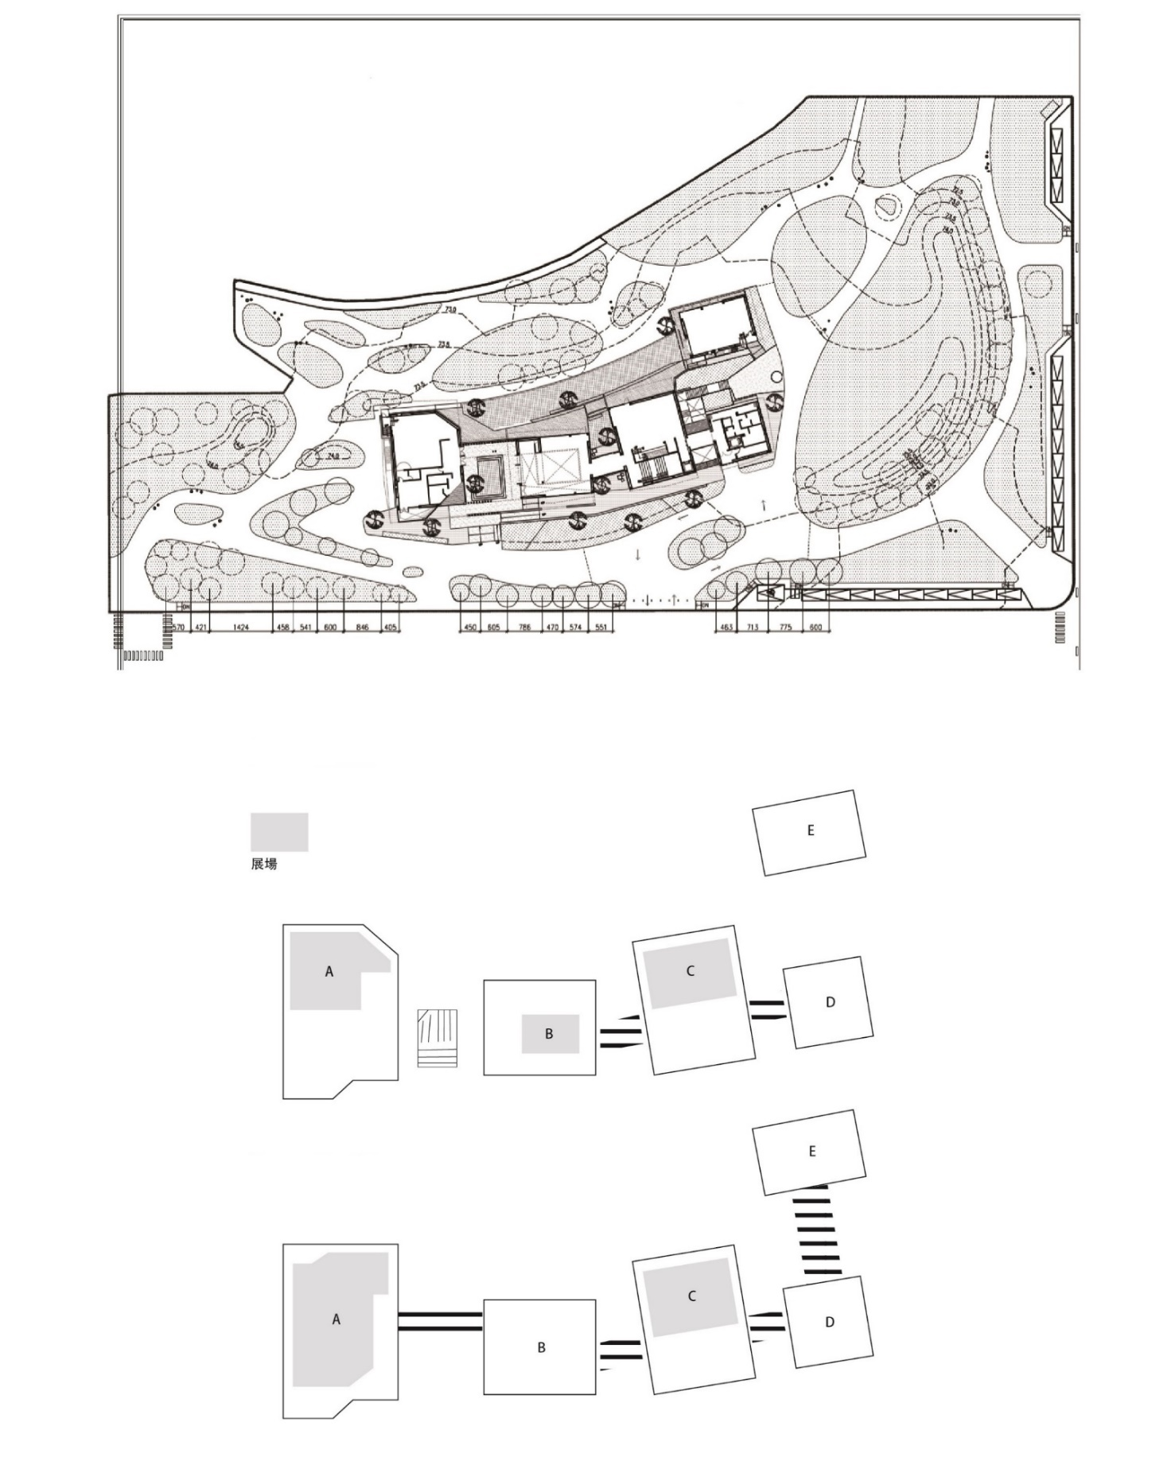

Floor Plan:
Building A, 1F (A1)
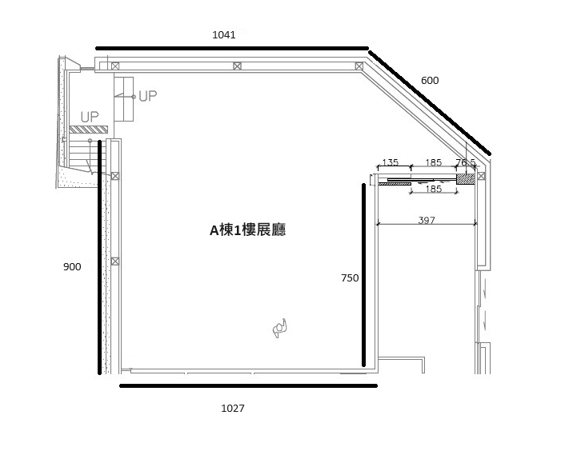
A1 Gallery
Building A, 2F (A2)
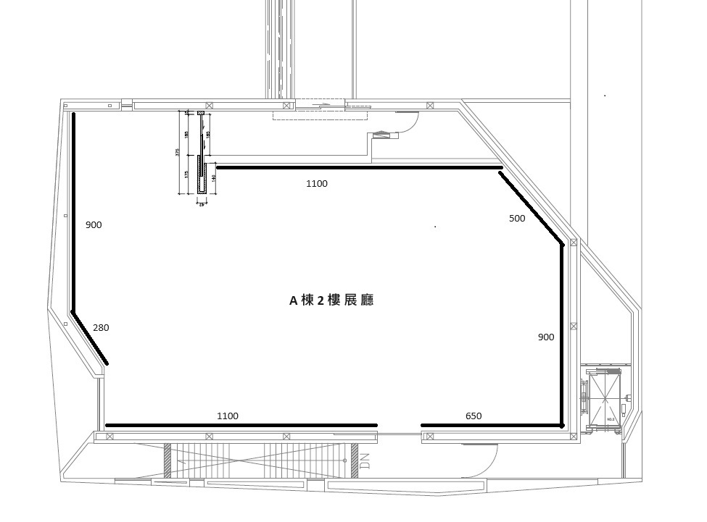

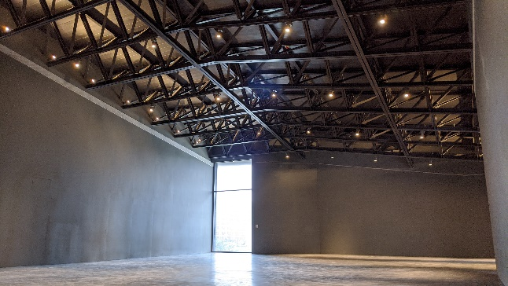
A2 Gallery
Building B, 1F (B1)
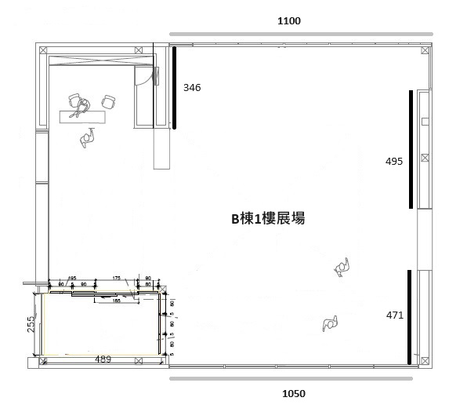
Building B, 2F (B2)
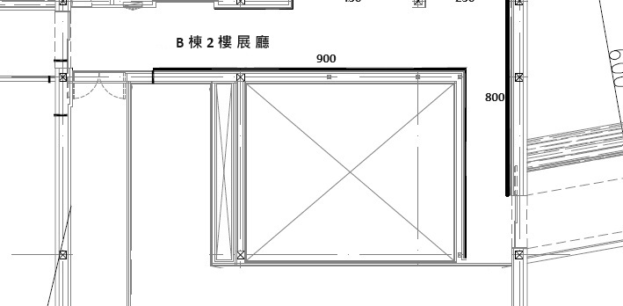
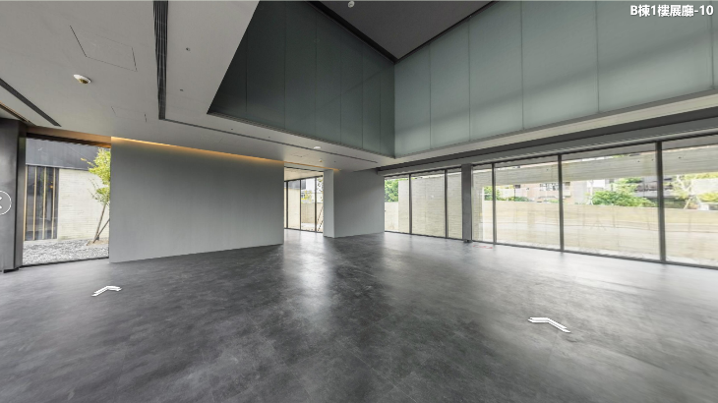
B1 Gallery
Building C, 1F (C1)
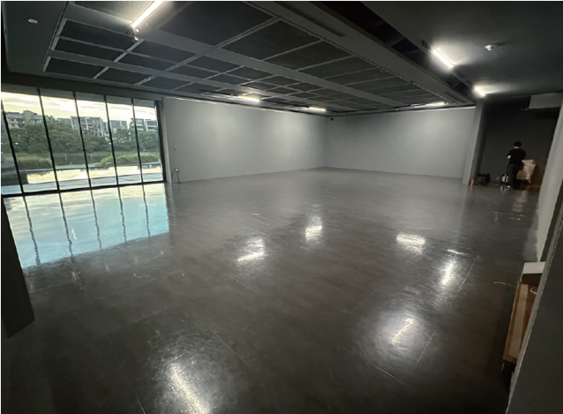
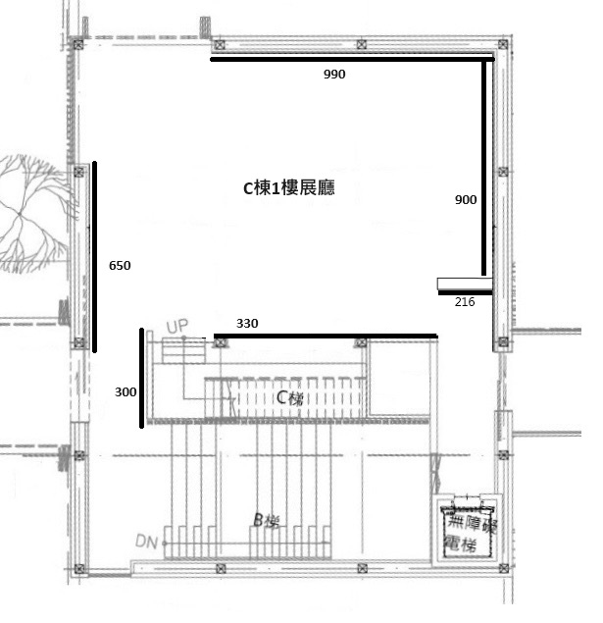
C1 Gallery
櫥窗
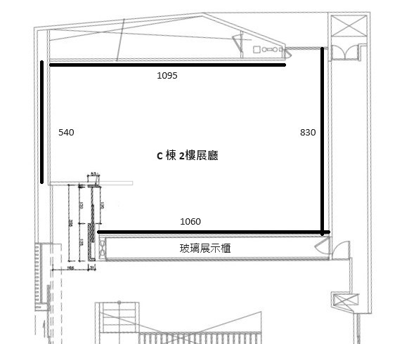
Building C, 2F (C2)

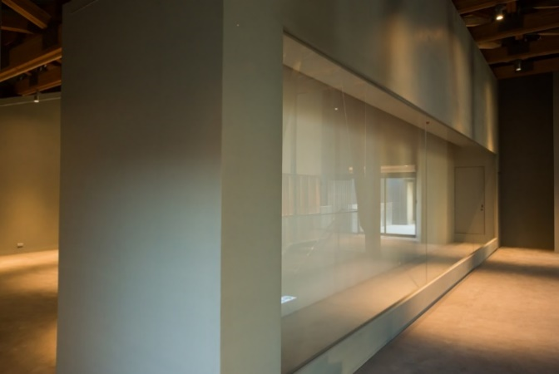
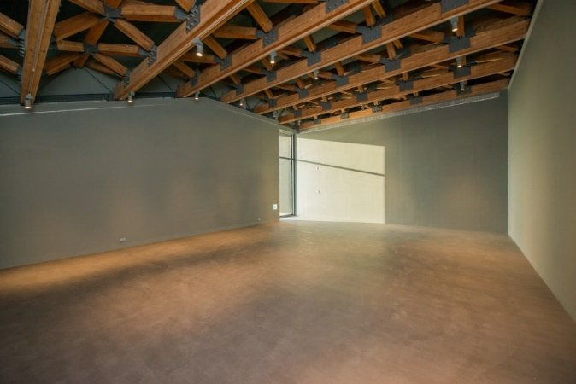
C2 Showcase
C2 Gallery
C棟2樓展場照片
C棟2樓櫥窗
Applicant and Participant Information Form: This form is for reference only.
Item | Information
Applicant / Group Representative | (Please also provide the Chinese name or name in Chinese characters, if applicable.)
Applicant / Representative’s National ID No., ARC No., or Passport No.
Contact Person | □ Same as above / □ Other:  (Please also provide the Chinese name or name in Chinese characters, if applicable.)
Contact Phone Number
Email
Contact Address | (Including postal code)
Notes | I hereby confirm that the above basic information and attached documents are true and accurate. If any information is found to be false, I agree that the Organizer may revoke my finalist, winner, or commissioned status, and I shall bear all legal responsibility.

Basic Information of Curator / Applicant Representative and Curatorial Statement

Exhibition Title
展覽名稱
Name of Curator / Exhibition Representative / Artist or Group
策展人/展覽代表人/藝術家(團體)名稱
Background of Exhibition Representative / Curator
展覽代表人/策展人經歷
List of Participants
(For group applications, please list all participating members in detail.)
參展者名單（團體請詳列參展人員）
Curatorial Statement
(English required; Chinese, Japanese, and Korean optional.)
策劃論述（英文必填，中、日、韓文選填）
(English Required, Approximately 1,000 words)

(Chinese, Japanese, or Korean Optional, Approximately 2,000 characters)

Notes | I hereby confirm that all information provided above is true and accurate. If any information is found to be false, I agree that the Organizer may revoke my finalist, winner, or commissioned status, and I shall bear all legal responsibility.
Reference List of Exhibition Works and Image Files
展覽作品參考資料表及作品圖檔
No.  編號 | Artist Name  作者姓名 | Title of Work  作品名稱 | Dimensions  作品尺寸 | Medium  作品媒材 | Image File  圖檔 | Notes  備註
If the space provided in this form is insufficient, please add rows as needed.

Exhibition Space or Artistic Presentation Site Design Drawings
展場或藝術表現現場設計圖
Building A, 1F (A1)
A棟1樓 (A1)
Building A, 2F (A2)
A棟2樓 (A2)
Building B, 1F (B1)
B棟1樓 (B1)
Building B, 2F (B2)
B棟2樓 (B2)
Building C, 1F (C1)
C棟1樓 (C1)
Building C, 2F (C2)
C棟2樓 (C2)
If the space provided in this form is insufficient, please add rows or pages as needed.

Educational and Public Program Plan, self-designed format
教育推廣活動規劃（格式自擬）

Budget and Itemized Details (Unit: New Taiwan Dollars, NT$)
經費預算及分項明細（單位：新臺幣元）
Category  項目 | Item  項次 | Content  內容 | Quantity  數量 | Unit  單位 | Unit Price  單價 | Total Amount  總額 | Description  預算說明
I. Personnel Expenses  人事費 | 1 | Curatorial fee
I. Personnel Expenses  人事費 | 2 | Fees related to participating artists
II. Exhibition Design and Production Expenses  展示設計與施作費 | 1
II. Exhibition Design and Production Expenses  展示設計與施作費 | 2
III. Artwork Transportation and Installation / De-installation Expenses  作品運輸與佈卸展費 | 1
 | 2
IV. Materials and Equipment Expenses  材料、設備費 | 1
IV. Materials and Equipment Expenses  材料、設備費 | 2
V. Insurance Expenses  保險費 | 1
V. Insurance Expenses  保險費 | 2
VI. Other Expenses  其它 | 1
VI. Other Expenses  其它 | 2
Total
Notes:
- Please prepare the budget according to the applicable budget amount, tax included, for the application category.
- If the space provided in this form is insufficient, please add rows as needed.

Work Schedule, self-designed format
工作期程（格式自擬）

Consent Form from Participating Artist / Lender

I, __________________, hereby agree to participate in the proposal submitted by the curator/group __________________ for the “Third Hengshan Calligraphy Award.” If the proposal is approved through the Organizer’s review process and commissioned for exhibition production, I agree to exhibit my work/collection ____________________________________________.
With respect to the relevant work/collection, including artist information, related texts, audiovisual records, and other relevant materials, I hereby grant Taoyuan Museum of Fine Arts | Hengshan Calligraphy Art Center a non-exclusive, royalty-free license to use the copyright within the scope required for this Award and the commissioned exhibition. The Organizer may publicly display and publicly transmit the materials at the time, place, and in the manner it determines. In the case of audiovisual works, this authorization also includes public broadcast and public screening.
The Organizer may also use the above materials on the platforms of Taoyuan Museum of Fine Arts, Hengshan Calligraphy Art Center, the Organizer’s partner media, and online platforms for exhibition-related publicity, editing, promotion, documentation, and archival purposes.
When using the above materials, the Organizer shall indicate the name of the author in a reasonable manner. Without consent, the Organizer shall not distort, mutilate, or otherwise alter the work in a way that damages the author’s reputation. The authorization granted under this Consent Form does not affect my copyright in the original work.
Artist:
Image File of Work:
Information on Work:
Person Giving Consent, Signature / Seal:
National ID No. / ARC No. / Passport No.:
Contact Phone Number:
Contact Address:
Email:
Date: Year / Month / Day

Undertaking and Personal Data Statement

Undertaking
I hereby participate in the “Third Hengshan Calligraphy Award” and fully agree to comply with all relevant provisions of the Guidelines. I confirm that all information provided is true and accurate. In the event of any violation, I shall bear all legal responsibility. The Organizer has the right to revoke my finalist, winner, or commissioned status, recover any cash award and related funding already paid, and claim damages.
This Undertaking shall take effect from the date of my signature.
To:
Taoyuan Museum of Fine Arts | Hengshan Calligraphy Art Center
Person Giving Undertaking: ____________________________ Signature
National ID No. / ARC No. / Passport No.:
Date: Year / Month / Day

Personal Data Statement and Consent Form
I acknowledge that Taoyuan Museum of Fine Arts, hereinafter referred to as the Organizer, collects, processes, and uses the personal data provided by me in the application materials within the necessary scope of the following specific purposes related to the “Third Hengshan Calligraphy Award”: application processing, review, award presentation, exhibition, printing, publication, academic research, educational promotion, publicity and marketing, performance of commissioned contracts, tax filing, and related matters.
The personal data collected, processed, and used may include name, date of birth, National ID No. / ARC No. / Passport No., contact phone number, address, email, educational and professional background, and other relevant information.
The period of use of personal data shall begin from the time of collection and continue until ten years after the announcement of the winner. After the retention period expires, the Organizer shall destroy the personal data, unless otherwise provided by law.
The area of use shall include the territory of the Republic of China, Taiwan, as well as areas reached by the Organizer’s website, partner media, and online platforms. The recipients of use shall include the Organizer and entrusted institutions necessary for the Organizer’s handling of this Award.
I may exercise my rights under Article 3 of the Personal Data Protection Act, including the rights to inquire, review, request copies, supplement or correct, request cessation of collection, processing, or use, and request deletion.
I may freely choose whether to provide my personal data. However, failure to provide personal data, or provision of incomplete personal data, may prevent completion of the application or affect the review process.
I have read and understood the above notice, and I agree that the Organizer may collect, process, and use my personal data within the above scope.
To:
Taoyuan Museum of Fine Arts | Hengshan Calligraphy Art Center
Person Giving Consent: ____________________________ Signature
National ID No. / ARC No. / Passport No.:
Date: Year / Month / Day

Consent Form and Personal Data Statement for Joint Production of Application Proposal
Applicable to co-creators of the application proposal.

Consent Form for Joint Production of Application Proposal

The Third Hengshan Calligraphy Award
I hereby participate in the joint production of the application proposal for the “Third Hengshan Calligraphy Award.” I agree that the applicant representative __________________ shall apply for this Award on my behalf, exercise the relevant rights related to participation in this Award, and perform the relevant obligations.
To:
Taoyuan Museum of Fine Arts | Hengshan Calligraphy Art Center
Person Giving Consent: ____________________________ Signature
National ID No. / ARC No. / Passport No.:

Personal Data Statement and Consent Form
I acknowledge that Taoyuan Museum of Fine Arts, hereinafter referred to as the Organizer, collects, processes, and uses the personal data provided by me in the application materials within the necessary scope of the following specific purposes related to the “Third Hengshan Calligraphy Award”: application processing, review, award presentation, exhibition, printing, publication, academic research, educational promotion, publicity and marketing, performance of commissioned contracts, tax filing, and related matters.
The personal data collected, processed, and used may include name, date of birth, National ID No. / ARC No. / Passport No., contact phone number, address, email, educational and professional background, and other relevant information.
The period of use of personal data shall begin from the time of collection and continue until ten years after the announcement of the winner. After the retention period expires, the Organizer shall destroy the personal data, unless otherwise provided by law.
The area of use shall include the territory of the Republic of China, Taiwan, as well as areas reached by the Organizer’s website, partner media, and online platforms. The recipients of use shall include the Organizer and entrusted institutions necessary for the Organizer’s handling of this Award.
I may exercise my rights under Article 3 of the Personal Data Protection Act, including the rights to inquire, review, request copies, supplement or correct, request cessation of collection, processing, or use, and request deletion.
I may freely choose whether to provide my personal data. However, failure to provide personal data, or provision of incomplete personal data, may prevent completion of the application or affect the review process.
I have read and understood the above notice, and I agree that the Organizer may collect, process, and use my personal data within the above scope.
To:
Taoyuan Museum of Fine Arts | Hengshan Calligraphy Art Center
Date: Year / Month / Day

Group Authorization Letter and Personal Data Statement
Applicable to group applicants.

Group Authorization Letter for Application

The Third Hengshan Calligraphy Award
This group hereby participates in the “Third Hengshan Calligraphy Award” and fully agrees to comply with all relevant provisions of the Guidelines. The members of this group jointly designate __________________, National ID No. / ARC No. / Passport No. __________________, as the representative of this group, and authorize the representative to exercise the relevant rights and perform the relevant obligations related to this Award.
To:
Taoyuan Museum of Fine Arts | Hengshan Calligraphy Art Center
Signatories, all group members must sign and provide their National ID No. / ARC No. / Passport No.:

Personal Data Statement and Consent Form
I acknowledge that Taoyuan Museum of Fine Arts, hereinafter referred to as the Organizer, collects, processes, and uses the personal data provided by me in the application materials within the necessary scope of the following specific purposes related to the “Third Hengshan Calligraphy Award”: application processing, review, award presentation, exhibition, printing, publication, academic research, educational promotion, publicity and marketing, performance of commissioned contracts, tax filing, and related matters.
The personal data collected, processed, and used may include name, date of birth, National ID No. / ARC No. / Passport No., contact phone number, address, email, educational and professional background, and other relevant information.
The period of use of personal data shall begin from the time of collection and continue until ten years after the announcement of the winner. After the retention period expires, the Organizer shall destroy the personal data, unless otherwise provided by law.
The area of use shall include the territory of the Republic of China, Taiwan, as well as areas reached by the Organizer’s website, partner media, and online platforms. The recipients of use shall include the Organizer and entrusted institutions necessary for the Organizer’s handling of this Award.
I may exercise my rights under Article 3 of the Personal Data Protection Act, including the rights to inquire, review, request copies, supplement or correct, request cessation of collection, processing, or use, and request deletion.
I may freely choose whether to provide my personal data. However, failure to provide personal data, or provision of incomplete personal data, may prevent completion of the application or affect the review process.
I have read and understood the above notice, and I agree that the Organizer may collect, process, and use my personal data within the above scope.
To:
Taoyuan Museum of Fine Arts | Hengshan Calligraphy Art Center
Date: Year / Month / Day

Consent Form from Legal Guardian

The Third Hengshan Calligraphy Award
Applicable to applicants under the age of 18.
The person giving consent is the legal guardian of the following applicant:
Applicant’s Name: ______________________________
Date of Birth: Year ______ Month ______ Day ______
National ID No. / ARC No. / Passport No.: ______________________________
The person giving consent hereby agrees that the above applicant may apply for the “Third Hengshan Calligraphy Award,” hereinafter referred to as this Award, and declares and agrees to the following:
- The person giving consent and the applicant have both carefully read the Guidelines for the Third Hengshan Calligraphy Award, hereinafter referred to as the Guidelines, and agree that the applicant may participate in this Award in accordance with the Guidelines and relevant regulations, exercise the relevant rights related to participation in this Award, and perform the relevant obligations.
- The applicant’s application for this Award and all documents signed by the applicant, including application materials, consent forms from participating artists/lenders, undertakings, personal data statement and consent forms, consent forms for joint production of the application proposal, group authorization letters, disclosure statements on the use of generative artificial intelligence, and other related documents, have all been approved in advance by the person giving consent. The person giving consent also acknowledges their legal effect.
- If the applicant is selected as a finalist or winner, the person giving consent agrees that the applicant may attend the final review meeting, accept the commission from the Organizer to organize the exhibition, and participate in promotional activities related to this Award. If the applicant signs a commissioning contract with the Organizer, the person giving consent shall grant permission or act on the applicant’s behalf in accordance with the law.
- The person giving consent acknowledges and agrees that the Organizer may, in accordance with the Personal Data Protection Act and the “Personal Data Protection” section of the Guidelines, collect, process, and use the personal data of the applicant and the person giving consent as stated in this Consent Form within the scope necessary for handling this Award.
If the applicant has two or more legal guardians, all legal guardians shall jointly sign this Consent Form.
To:
Taoyuan Museum of Fine Arts | Hengshan Calligraphy Art Center
Signature of Person Giving Consent, Legal Guardian 1: ______________________________
Relationship to Applicant: □ Father □ Mother □ Guardian □ Other: __________________
National ID No. / ARC No. / Passport No.: ______________________________
Contact Phone Number: __________________
Contact Address: ______________________________
Signature of Person Giving Consent, Legal Guardian 2: ______________________________
Relationship to Applicant: □ Father □ Mother □ Guardian □ Other: __________________
National ID No. / ARC No. / Passport No.: ______________________________
Contact Phone Number: __________________
Contact Address: ______________________________
Date: Year ______ Month ______ Day ______

Disclosure Statement on the Use of Generative Artificial Intelligence

The Third Hengshan Calligraphy Award
In accordance with the Notes in the Guidelines for the Third Hengshan Calligraphy Award, hereinafter referred to as the Guidelines, submitted works, curatorial statements, images of works, exhibition-space design drawings, and other creative content must not be generated in whole or in substantial part by generative artificial intelligence, including but not limited to large language models, image-generation models, and text-to-image models. Applicants who use generative artificial intelligence as an auxiliary tool during the creative or planning process must provide a specific written disclosure at the time of application.
I hereby declare the following. Please check one option:
□ No Use: No generative artificial intelligence was used to generate any part of this application proposal, including works, curatorial statement, images of works, exhibition-space design drawings, and other creative content.
□ Used, limited to auxiliary use: The usage is disclosed item by item in the table below.
No. | Content Item in Which AI Was Used | Tool Name and Version | Purpose | Specific Description of Scope of Use | Percentage of Final Result, %
1
2
3
Examples of purposes: text polishing, data organization, sketch ideation, translation, etc.
If the space provided in this form is insufficient, please add rows as needed.
I further declare and agree to the following:
- I warrant that the above disclosure is complete and truthful, and that this application proposal has not been generated in whole or in substantial part by generative artificial intelligence.
- If I violate the prohibitions set forth in the Guidelines or provide false disclosure, I agree that the Organizer may handle the matter in accordance with the Notes in the Guidelines, including suspending the exercise of my rights, revoking my application, finalist, or winner status, and recovering any cash awards and funding already paid.
- I agree that the Organizer may verify the above disclosure within the scope necessary for review and examination, and may notify me to provide supplementary explanations within a specified period.
To:
Taoyuan Museum of Fine Arts | Hengshan Calligraphy Art Center
Declarant, Signature: ______________________________
National ID No. / ARC No. / Passport No.: ______________________________
If the applicant is under the age of 18, this Statement shall also be signed by the legal representative: ______________________________
Date: Year ______ Month ______ Day ______

